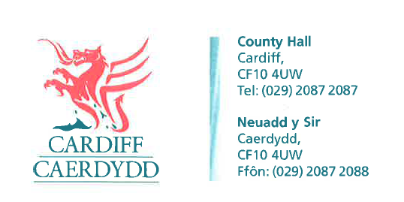
FOI Response Document
FOI18209
Thank you for your request under the Freedom of Information Act 2000 about Disability Confident Scheme received on 01/08/2022.
Request:
I would like to know the date when Cardiff Council joined the Disability Confident scheme and the date when the Council passed Stage 1 ("Committed") to reach Stage 2 ("Employer"). My reason for asking is that Cardiff Council is not included in the most recent list of Disability Confident Employers published by the DWP.
The Council could have joined the scheme any time between November 2016 and the present.
We have considered your request and enclose the following information:
I confirm that the Council transitioned from the previous Two Ticks Scheme to be recognised as a Level 2 Disability Confident Employer with effect from 19th December 2016.
Thank you for drawing our attention to the DWP listing – we will investigate this matter further.
If you have any queries or concerns, please do not hesitate to contact us.
Please remember to quote the reference number above in any future communications.

